|  |  |
| --- | --- |
| **Passive Optical Components** | **Fiber Optic Stripper** |
|  |  |

**The Fiber Optic Stripper is used for stripping 250 micron buffer coating from 125 micron optical fiber. Preset at the factory so no adjustments are necessary. Unique design prevents nicks or scratches on the optical fiber plus blades are ground and hardened for long life. Yellow plastic dipped handles.**

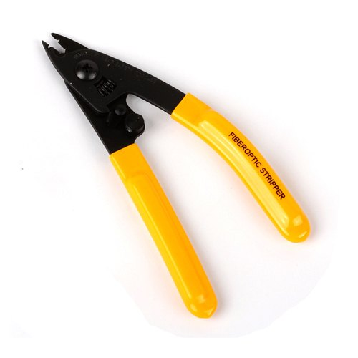

**Specifications**

|  |  |
| --- | --- |
| **Cut Type** | **Strip** |
| **Cable Type** | **Fiber Optic** |
| **Cable Diameter** | **250 micron, 125 micron** |
| **Handle** | **TPR (Thermoplastic Rubber)** |
| **Color** | **Yellow Handle** |
| **Length** | **5-3/16” (131.76mm)** |
| **Weight** | **0.266 lbs (120.66g)** |
| **UPC No** | **811490011465** |
|  |  |